Sharon Tisher slides for ClassAct forum
To be shown with my concluding remarks re action items (also: join/start a land trust, or an equivalent of Land for Maine’s Future in your state)
Which will be something like: The problem of climate change and the “Sixth Extinction” is indeed an “embarrassment of riches,” as is this photo, from the weekly real estate section of the WSJ, aptly named “Mansion.” Hats off to Mainer Yvon Chouinard, and my classmates, including participants on this panel, who have advocated for and enabled private equity to make major contributions to climate and biodiversity education, science, and policy. But much more can be done to move wealthy individuals and institutions to spend less money on trophy rooms and more on environmental protection. An apt subject for environmental forum part II?
Tisher comment in class: not so good for the carcasses hanging on the wall.
Continued:

Also possible, if we develop a focus on the Amazon:
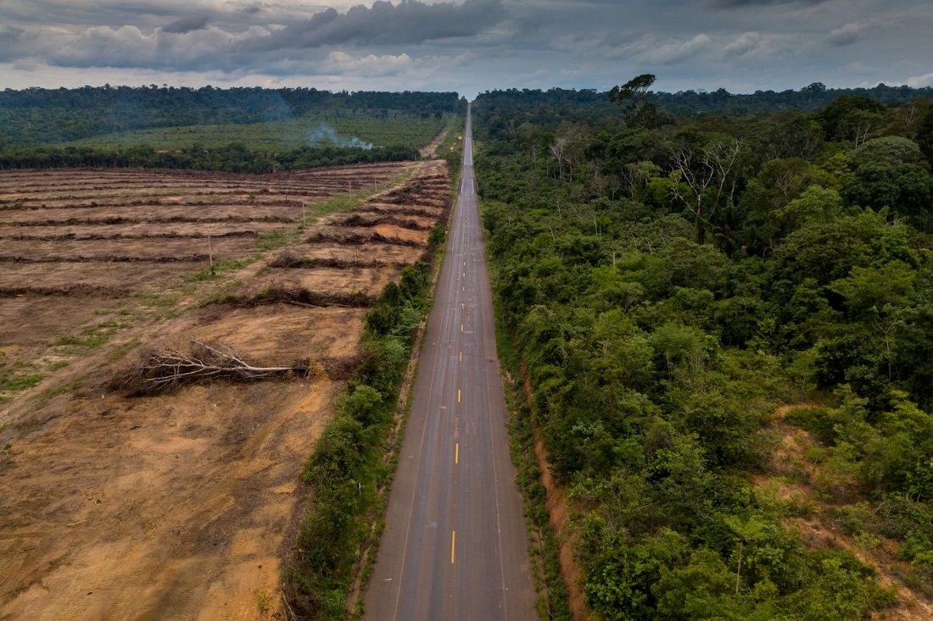
https://e360.yale.edu/features/for-the-kayapo-a-long-battle-to-save-their-amazon-homeland

[I do not have copyright permissions for use of these photos]

